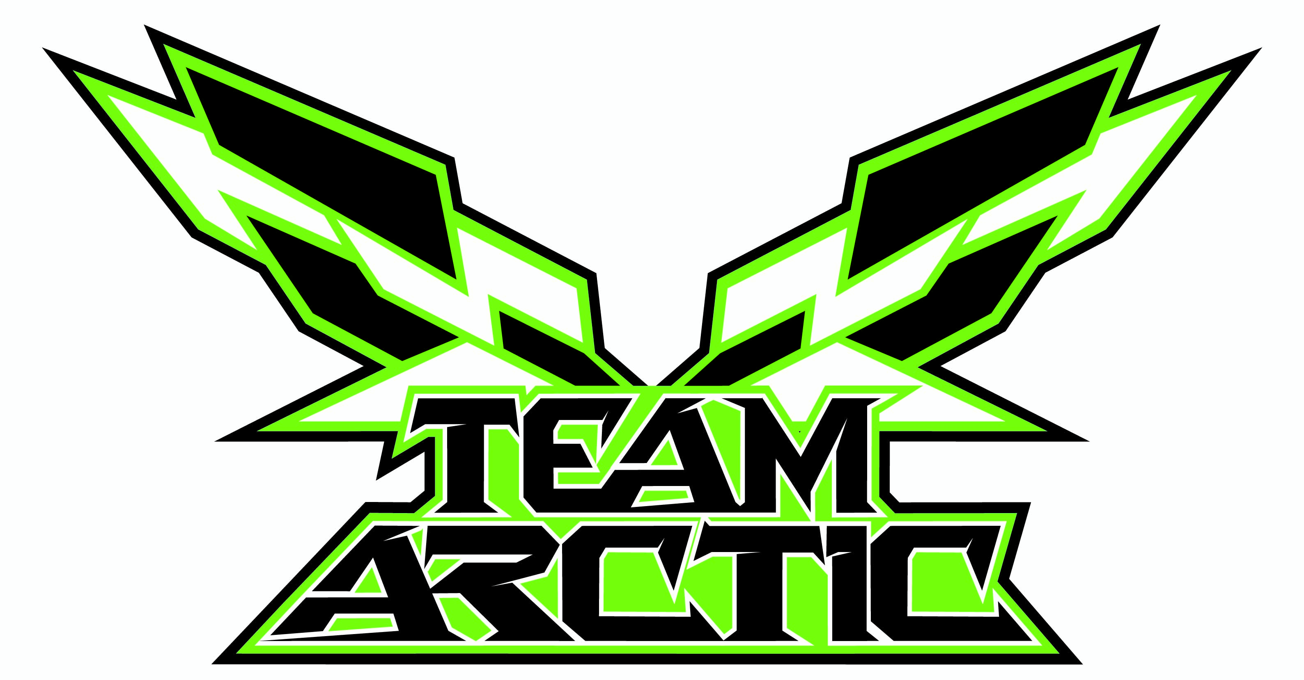

all-new 2012 Arctic cat sno Pro 600 unveiled at haydays
Hibbert to Defend Pro Points Championship aboard ProCross Race Chassis

Thief River Falls, Minn. (9/10/11) – The official start to winter kicked off today at the largest snowmobile event in the world – Haydays. Thousands of loyal Team Arctic race fans were treated to the first unveiling of the all-new 2012 Arctic Cat Sno Pro 600 race sled.

70’s fashion Icon, Cat Girl unveiled the all-new 2012 Sno Pro 600 and conducted a walk-around with Performance Product Team Manager Troy Halvorson. Halvorson said the all-new Sno Pro 600 will build upon last season’s winning success and the success of the recently introduced ProCross chassis. Key highlights include:
- All new ProCross Race chassis – Stronger and lighter than 2011 Sno Pro 600
- 600R race engine with 40mm Mikuni rack style TM carbs w/TPS
- Front Arctic Race Suspension (ARS) – with Fox Float X Evol Shox
- All-new Race Slide Action rear suspension equipped with Fox Racing Shox
- 1.7-in. Snocross track or 1.25-in. Cobra 2-ply Cross Country track
- Arctic Drive System (ADS) with magnesium chaincase and all-new Torque Overloading Sensing (TOS) bottom sprocket
- Torque Control Link (TCL) - Links the drive to driven clutch
- Radial Master Cylinder brake system
- 5 gallon Snocross or 12 gallon Cross Country fuel tank

“Racing has been a strong cornerstone of Arctic Cat’s heritage and brand. An arena we have consistently used for testing and development. It’s our commitment to race the ProCross chassis and show the world that our consumers can buy the same snowmobile to conquer the world’s toughest terrain,” said Brad Darling, GM Snow Division.

Defending his ISOC Pro Points Championship Title, Tucker Hibbert will race the full season aboard the all-new 2012 Sno Pro 600 as well as compete for his sixth-consecutive ESPN Winter X Games gold medal. If he wins, Hibbert will become the only athlete in the history of Winter X to six-peat. Hibbert has competed every year since 2000 and currently holds 10 medals, six of which are gold.

Arctic Cat CEO Claude Jordan stated, “Our talented engineers have built our best Sno Pro race sled to date, and that says a lot considering we won every major race or championship title last season. It’s going to be a tough year for our competition, but an even better year for our Team Arctic race fans!”

About Arctic Cat and Tucker Hibbert
Arctic Cat Inc., based in Thief River Falls, Minn., designs, engineers, manufactures and markets all-terrain vehicles (ATVs) and snowmobiles under the Arctic Cat® brand name, as well as related parts, garments and accessories. Its common stock is traded on the Nasdaq National Market under the ticker symbol “ACAT.” More information regarding the all-new 2012 Sno Pro 600, and other Arctic Cat products please log on to www.arcticcat.com or visit your local dealer. For more information on Tucker Hibbert, please log on to www.tucker-hibbert.com.
###

